**Question :**

ASSIGNMT 4

**Ultrasonic sensor simulation in Wokwi**

|  |  |
| --- | --- |
| Name | Praveen R |
| Register Number | 73771913149 |
| Team ID | PNT2022TMID11787 |
| Project Name | SIGNS WITH SMART CONNECTIVITY FOR BETTER ROAD SAFETY |
| Date | October 28,2022 |

Write a code and connections in wokwi for the ultrasonic sensor. Whenever the distance is less than

100cms send an “Alert” to IBM cloud and display in the device recent events.

**Code:**

#include<WiFi.h>#include<PubSubClient.h>voidcallback(char* subscribetopic,byte*payload,unsignedintpayloadLength);

//-------credentialsofIBMAccounts------

#defineORG"kotoq5"//IBMORGANITIONID

#defineDEVICE_TYPE"ESP32"//DevicetypementionedinibmwatsonIOTPlatform #defineDEVICE_ID"12345"//DeviceIDmentionedinibmwatsonIOTPlatform #defineTOKEN"12345678"//TokenStringdata3;charserver[]=

ORG".messaging.internetofthings.ibmcloud.com";char

publishTopic[] = "iot-2/evt/Data/fmt/json"; char subscribetopic[]="iot-2/cmd/test/fmt/String";char authMethod[]="use-token-auth";

char token[] = TOKEN;

charclientId[]="d:"ORG":"DEVICE_TYPE":"DEVICE_ID;

WiFiClient wifiClient;

PubSubClientclient(server,1883,callback,wifiClient); constinttrigPin=5;constintechoPin=18;#define SOUND_SPEED0.034longduration;floatdistance;void setup(){**Serial**.begin(115200);pinMode(trigPin, OUTPUT);pinMode(echoPin,INPUT);wificonnect(); mqttconnect();}voidloop(){digitalWrite(trigPin, LOW);delayMicroseconds(2);digitalWrite(trigPin,HIGH); delayMicroseconds(10);digitalWrite(trigPin,LOW); duration=pulseIn(echoPin,HIGH);distance=duration* SOUND_SPEED/2;

**Serial**.print("Distance(cm):");**Serial**.println(distance); if(distance<100)

{

**Serial**.println("ALERT!!"); delay(1000);

PublishData(distance)

;delay(1000);if (!client.loop()){ mqttconnect();

}}delay(1000);}void PublishData(floatdist){ mqttconnect();

Stringpayload="{\"Distance\":";payload+=dist;payload

+=",\"ALERT!!\":""\"Distancelessthan100cms\"";payload

+= "}";

**Serial**.print("Sending payload: ");

**Serial**.println(payload);

if(client.publish(publishTopic,(char*)payload.c_str())){

**Serial**.println("Publishok");

} else{

**Serial**.println("Publishfailed");

}}voidmqttconnect(){if (!client.connected()) { **Serial**.print("Reconnectingclientto"); **Serial**.println(server);

while(!!!client.connect(clientId,authMethod,token))

{**Serial**.print(".");delay(500);

}

initManagedDevice();

**Serial**.println();

} }

void wificonnect()

{

**Serial**.println();**Serial**.print("Connectingto"); WiFi.begin("Wokwi-GUEST","",6);while(WiFi.status()!= WL_CONNECTED) { delay(500);

**Serial**.print(".");

}

**Serial**.println("");**Serial**.println("WiFi connected");**Serial**.println("IPaddress:"); **Serial**.println(WiFi.localIP());

}

void initManagedDevice() { if (client.subscribe(subscribetopic)) { **Serial**.println((subscribetopic));**Serial**.println("subscribeto cmd OK");

} else{

**Serial**.println("subscribetocmdFAILED");

}}voidcallback(char*subscribetopic,byte*payload,unsignedint payloadLength)

{

**Serial**.print("callback invoked for topic: ");**Serial**.println(subscribetopic);for(int i=0;i<payloadLength;i++){

//Serial.print((char)payload[i]); data3+= (char)payload[i];

}

**Serial**.println("data:"+data3); data3="";

}

# Diagram.json:

{

"version":1,

"author":"sweetysharon", "editor":"wokwi", "parts": [

{"type":"wokwi-esp32-devkit-v1","id":"esp","top":-4.67,"left":-114.67,"attrs":{}

},

{"type":"wokwi-hc-sr04","id":"ultrasonic1","top":15.96,"left":89.17,"attrs":{}}

],

"connections": [

["esp:TX0","$serialMonitor:RX","",[]],

["esp:RX0","$serialMonitor:TX","",[]],

[

"esp:VIN", "ultrasonic1:VCC", "red",

["h-37.16","v-178.79","h200","v173.33","h100.67"]

],

["esp:GND.1","ultrasonic1:GND","black",["h39.87","v44.04","h170"]],

["esp:D5","ultrasonic1:TRIG","green",["h54.54","v85.07","h130.67"]],

["esp:D18","ultrasonic1:ECHO","green",["h77.87","v80.01","h110"]]

]

}

# Wokwi simulation link:

**https://wokwi.com/projects/346508314441417298**

# Circuit Diagram:

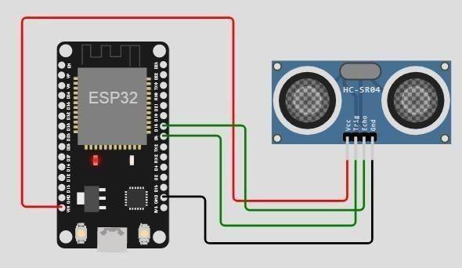

**Output:**

Wokwi output:

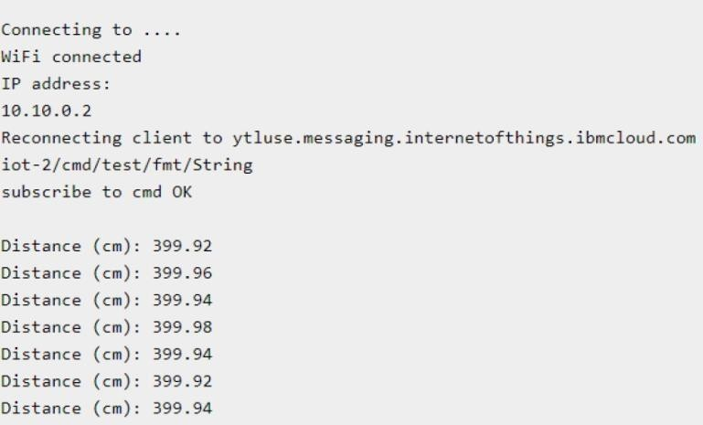

**IBM cloud output:**

